1. **Log4j**: Logging framework, reliable, fast, flexible, written in java and distributed under Apache Software License.
   1. 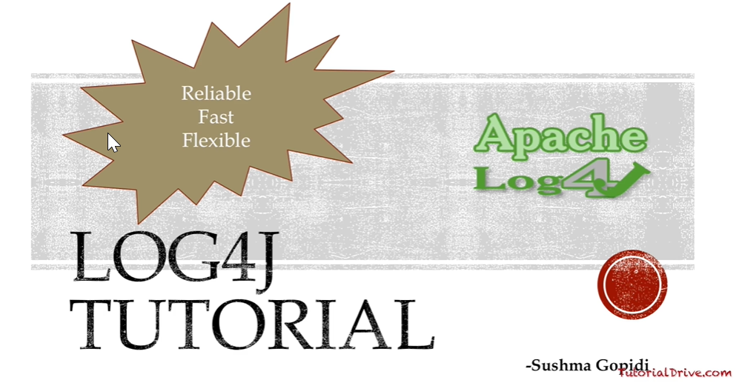 
2. 